* **Name of the Activity:** One-day workshop on “Sanskrit & World Literature”
* **Type of the Activity**: Workshop
* **Organizing Department**: Department of Sanskrit, Chakdaha College
* **Date and time of the Activity**: 29.02.2020 from 13.30 pm – 15.30 pm
* **Number of participants**: 76
* **Speakers:**
  + Dr. Anindya Bandopadhyay, Assistant Professor & HOD, Department of Sanskrit, University of Kalyani.
  + Dr. Pampa Chakraborty, Assistant Professor, Department of Sanskrit, Ranaghat College.
  + Dr. Arijit Gupta, Assistant Professor, Department of Sanskrit, Dwijendralal College.

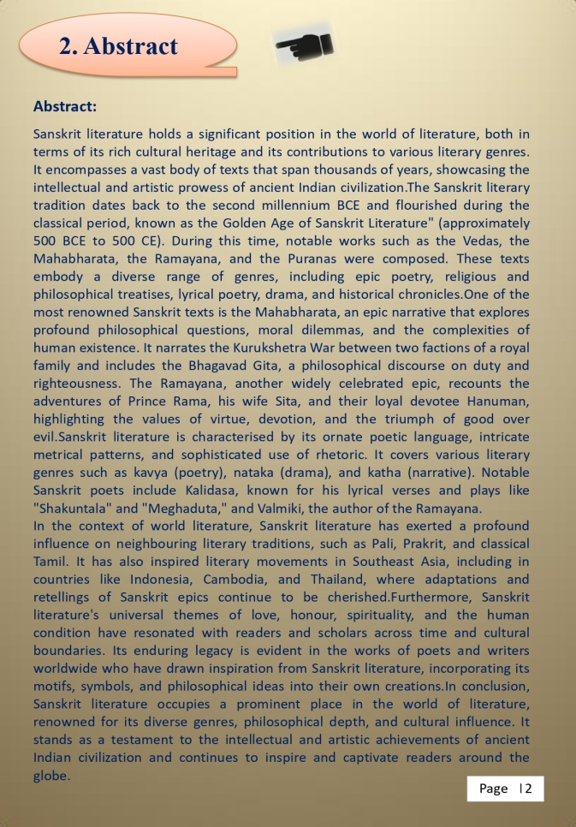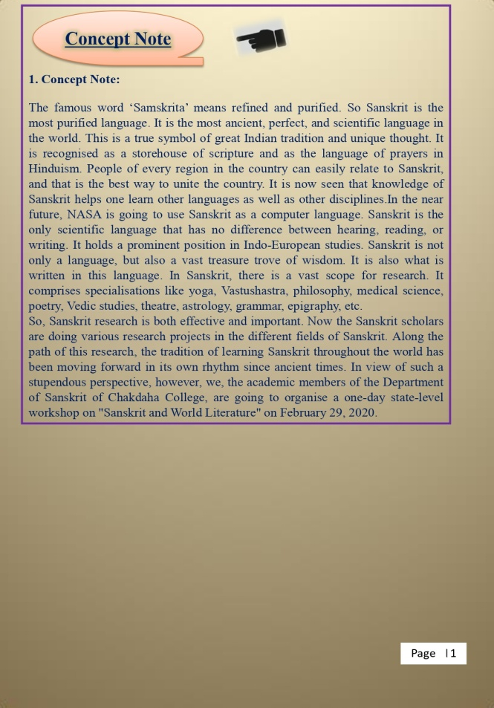

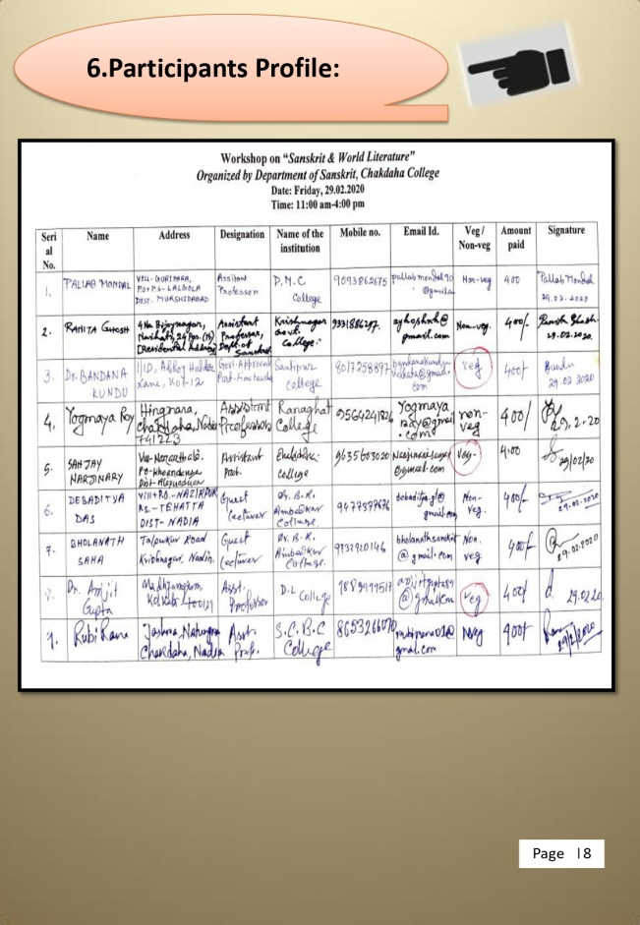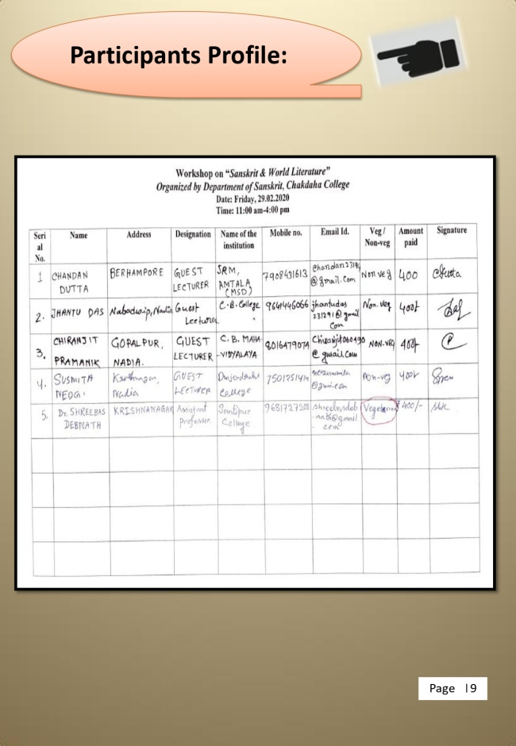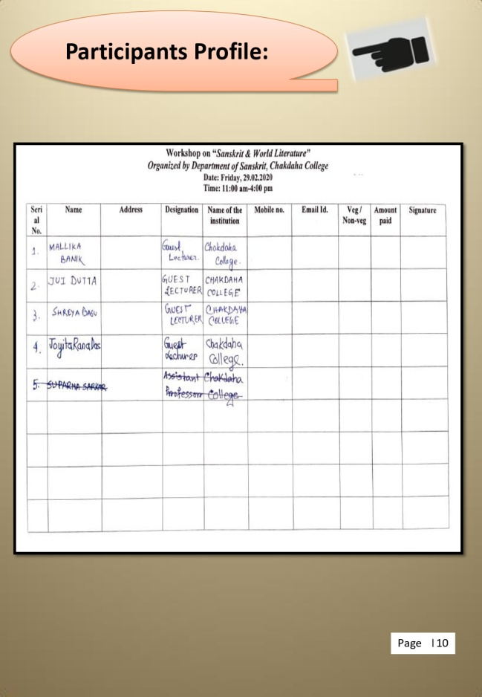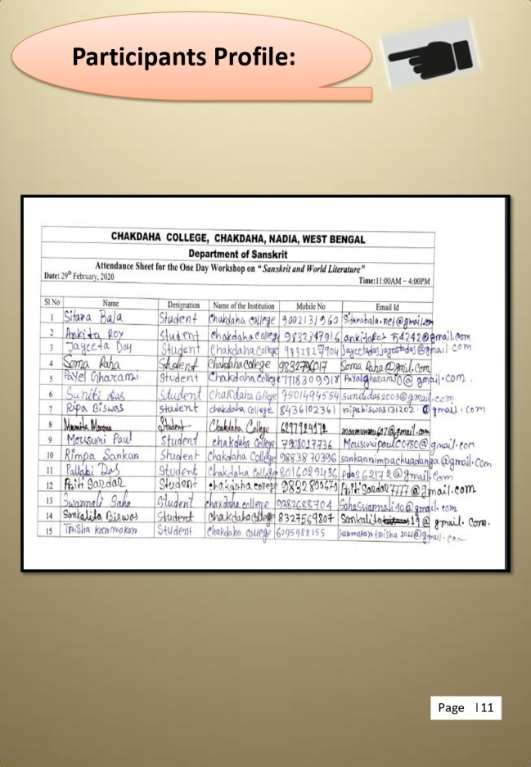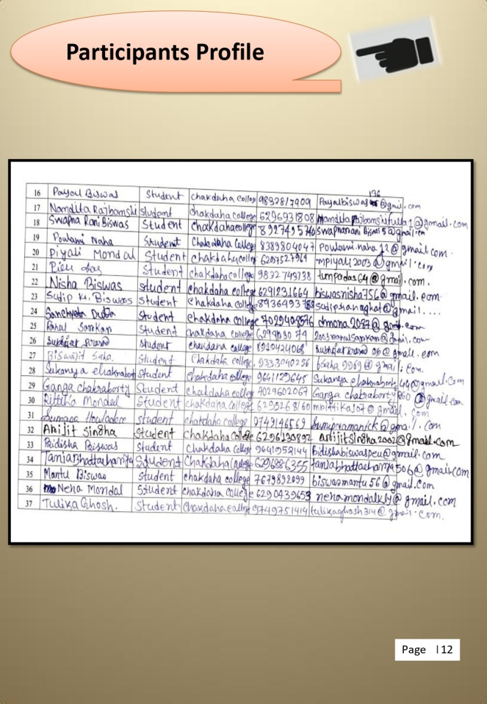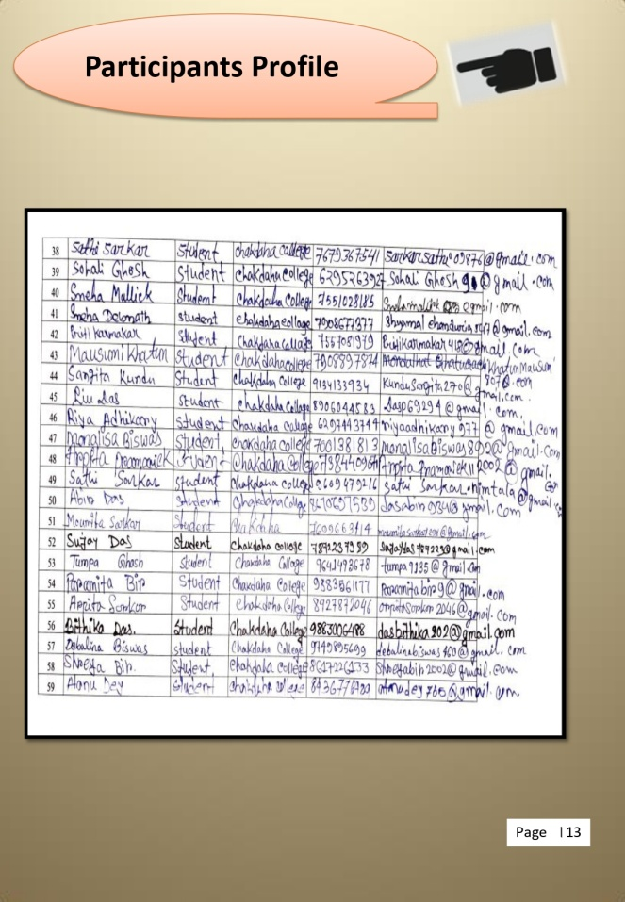

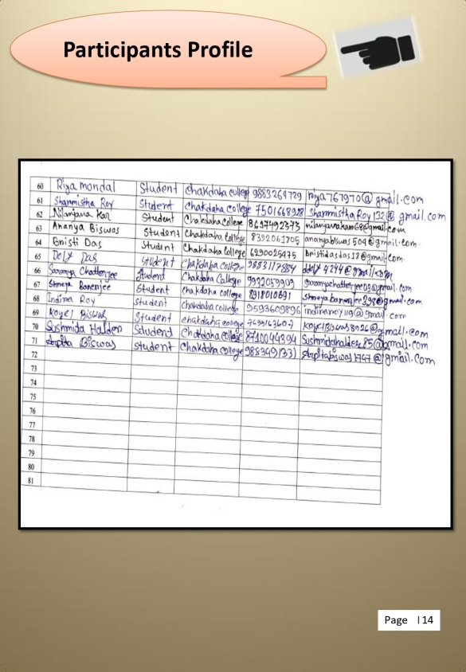

H. Photograph of the Programme:

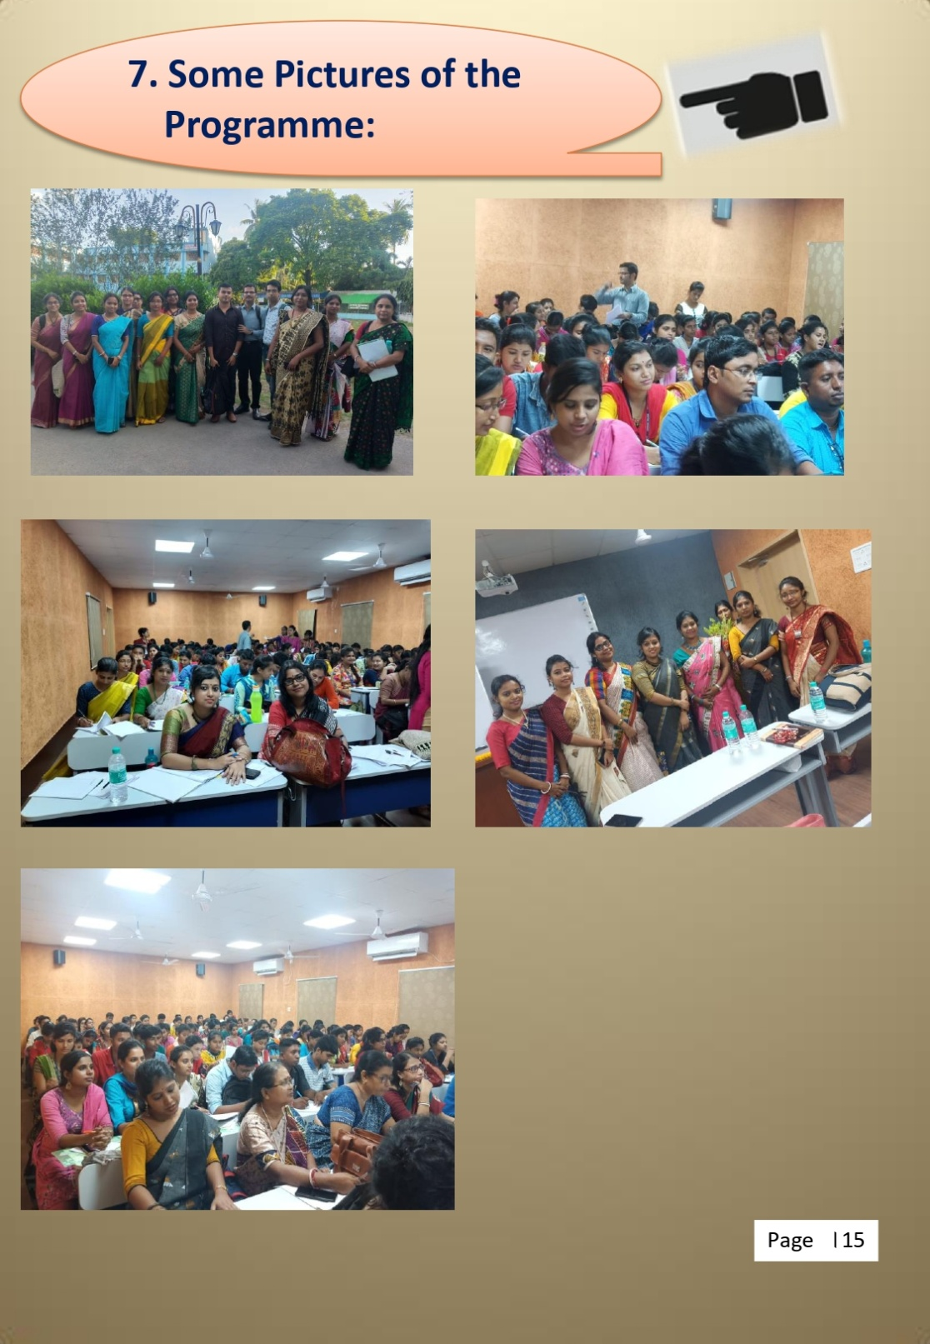

**Relevant Web Link:**

<https://www.facebook.com/photo/?fbid=332331851960784&set=pcb.332333015294001>